DRIPPY THE RAINDROP

Prepiši besede v zvezek - eno pod drugo.
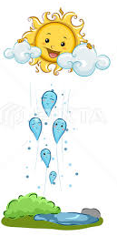
vapour – para
to cool off – ohladiti se
other raindrops – druge dežne kapljice
travel – potovati
towards the mountains – proti goram
suddenly – nenadoma

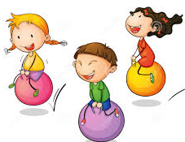
bounce – odbijati se

the ground – tla
leaf – list
to slide – zdrsniti
excited – vznemirjen
to float – lebdeti
a trip - izlet

